Assignment 28.3

Problem Statement:

link:emp_details.txt

Use Hive Scripts to run the below queries.

● Get a list of employees who receive a salary less than 100, compared to their immediate employee with higher salary in the same unit

● List of all employees who draw higher salary than the average salary of that department



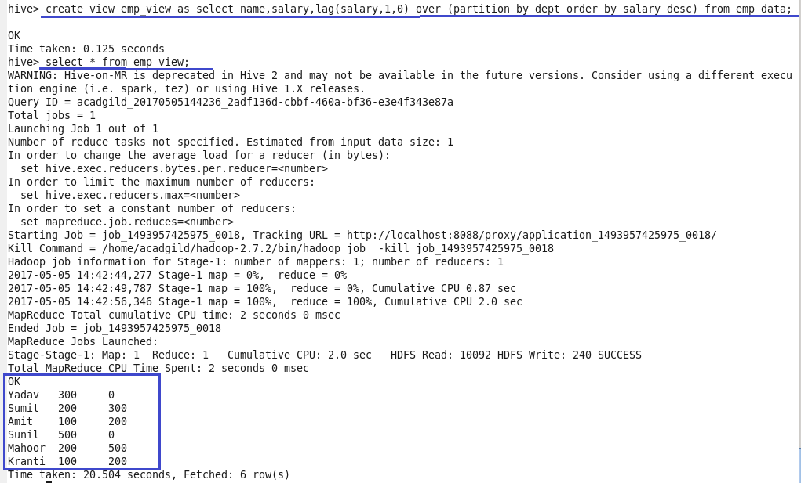

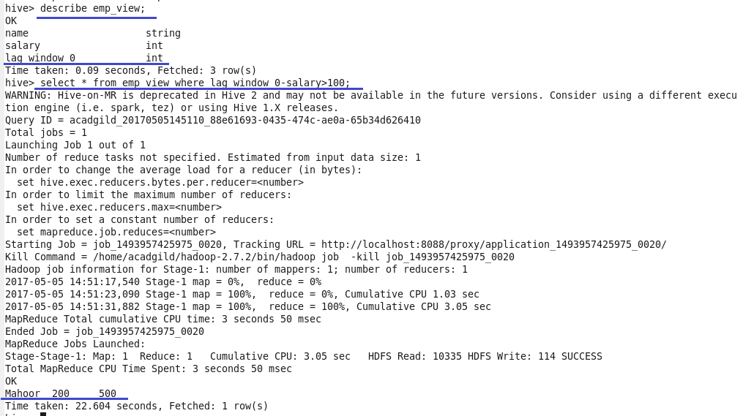

● List of all employees who draw higher salary than the average salary of that department

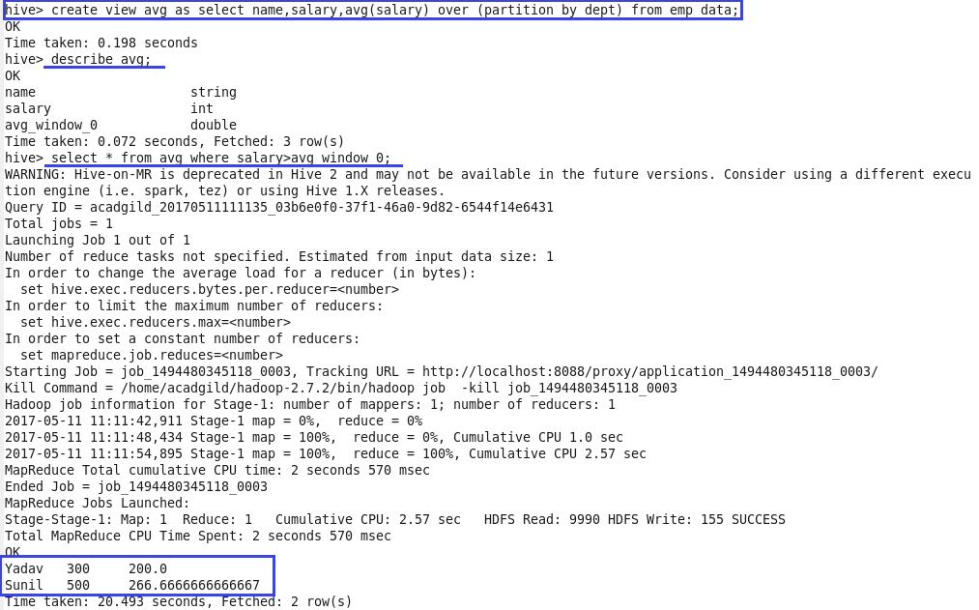

Problem Statement:

Link: olympic_data.csv Store the above dataset into the following file formats.

● SEQUENCEFILE ● RCFILE ● ORC FILE Share the commands used with their results.

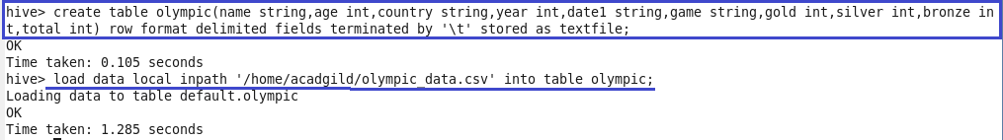

Sequence file

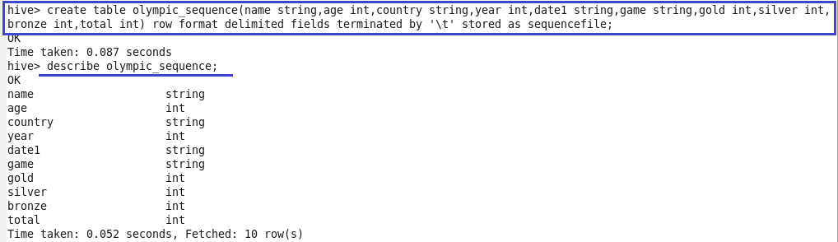

Data loaded into sequence file format.

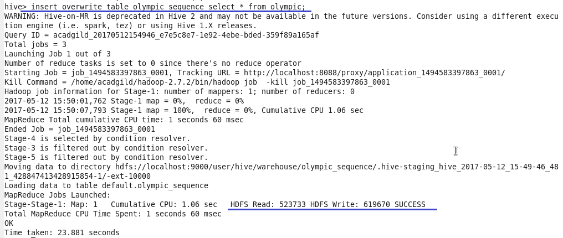

RC file

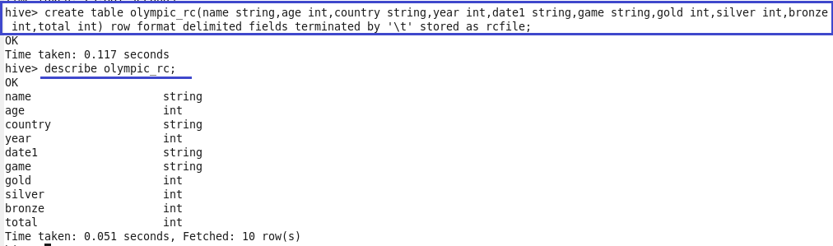

Data loaded into RC file format

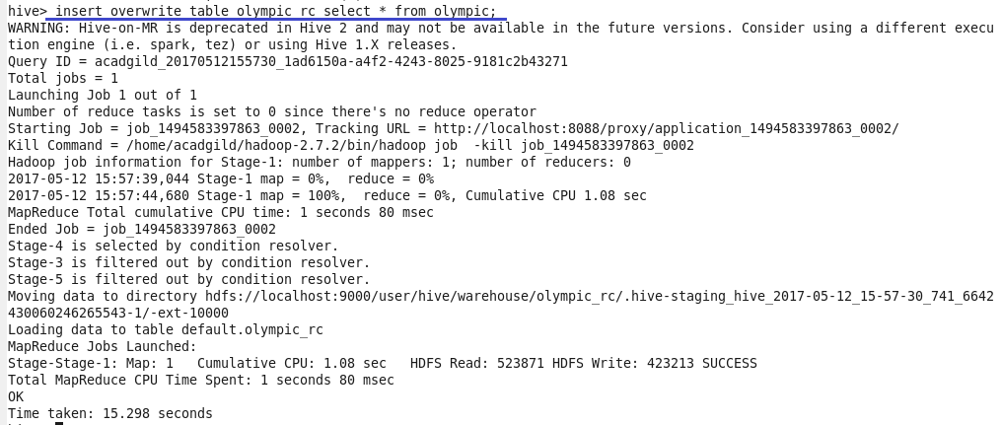

ORC file

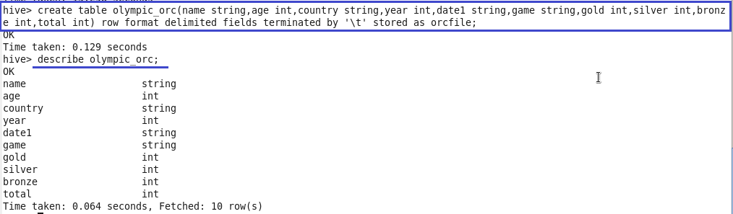

Data loaded into ORC file

